Ali Ahmed Fathi
Open-Source Track
RHSA1 Lab 1
1. Install Ubuntu.
2. What is the difference between cat and more command?
Sol.
- Cat displays the contents of the file. It helps us to create, view, concatenate files.
- More displays one screen at a time in case the file is large. When the output is large, we can use more command to see output one by one.

3. What is the difference between rm and rmdir using man?
Sol.

- rm removes references to objects from the filesystem, where those objects might have had multiple references. By default, it does not remove directories.
- rmdir remove empty directories.

4. Create the following hierarchy under your home directory:
Sol.
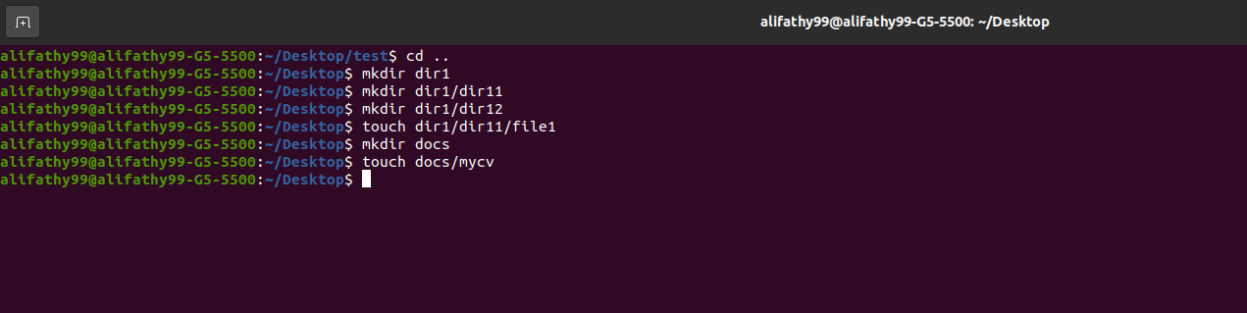
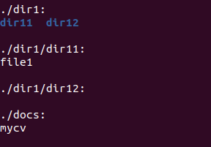

a. Remove dir11 in one-step. What did you notice? And how did you overcome that?

rm dir1/dir11 doesn’t remove dir11 because it is not empty and to overcome that we use rm -r dir1/dir11 which removes dir11 with its data
b. Then remove dir12 using rmdir –p command. State what happened to the hierarchy (Note: you are in your home directory).
It will remove dir12 and there is no ancestors inside dir12 to remove them.

c. The output of the command pwd was /home/user. Write the absolute
and relative path for the file mycv

Absolute path:
cd /home/alifathy99/~Desktop/docs/mycv
Relative path:
cd /docs/mycv/

5. Copy the /etc/passwd file to your home directory making its name is mypasswd.

6. Rename this new file to be oldpasswd.
7. You are in /usr/bin, list four ways to go to your home directory

First way:
Second way:
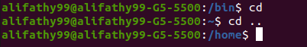

Third way:
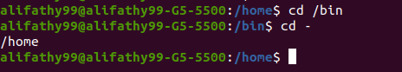

Fourth way:
8. List Linux commands in /usr/bin that start with letter w
9. Display the first 4 lines of /etc/passwd

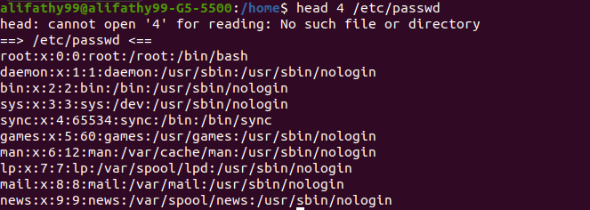
10. Display the last 7 lines of /etc/passwd

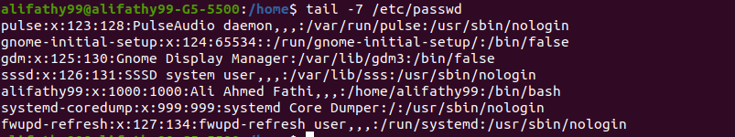
11. Display the man pages of passwd the command and the file sequentially in one command.

12. Display the man page of the passwd file.
13. Display a list of all the commands that contain the keyword passwd in their man page.

